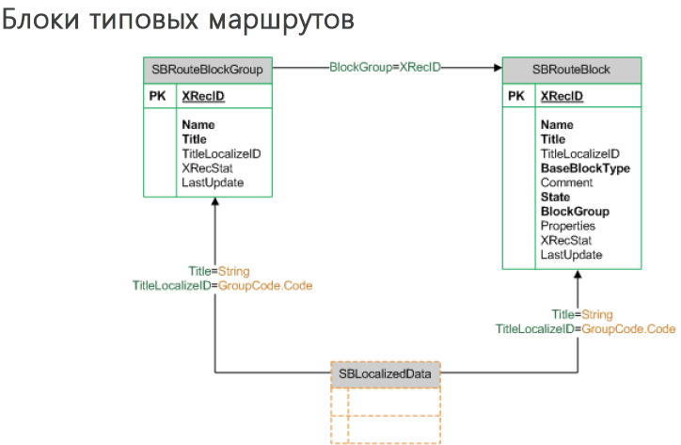

[SBLocalizedData](file:///D:\%25D0%2594%25D0%25BE%25D0%25BA%25D1%2583%25D0%25BC%25D0%25B5%25D0%25BD%25D1%2582%25D0%25B0%25D1%2586%25D0%25B8%25D1%258F%20Directum\DIRECTUM%205.6\Docs\%25D0%2594%25D0%25BB%25D1%258F%20%25D1%2580%25D0%25B0%25D0%25B7%25D1%2580%25D0%25B0%25D0%25B1%25D0%25BE%25D1%2582%25D1%2587%25D0%25B8%25D0%25BA%25D0%25B0\DIRECTUM%205.6.%20%25D0%25A4%25D0%25B8%25D0%25B7%25D0%25B8%25D1%2587%25D0%25B5%25D1%2581%25D0%25BA%25D0%25B0%25D1%258F%20%25D1%2581%25D1%2582%25D1%2580%25D1%2583%25D0%25BA%25D1%2582%25D1%2583%25D1%2580%25D0%25B0%20%25D0%25B4%25D0%25B0%25D0%25BD%25D0%25BD%25D1%258B%25D1%2585.PDF#page=111)

[SBRouteBlockGroup](file:///D:\%25D0%2594%25D0%25BE%25D0%25BA%25D1%2583%25D0%25BC%25D0%25B5%25D0%25BD%25D1%2582%25D0%25B0%25D1%2586%25D0%25B8%25D1%258F%20Directum\DIRECTUM%205.6\Docs\%25D0%2594%25D0%25BB%25D1%258F%20%25D1%2580%25D0%25B0%25D0%25B7%25D1%2580%25D0%25B0%25D0%25B1%25D0%25BE%25D1%2582%25D1%2587%25D0%25B8%25D0%25BA%25D0%25B0\DIRECTUM%205.6.%20%25D0%25A4%25D0%25B8%25D0%25B7%25D0%25B8%25D1%2587%25D0%25B5%25D1%2581%25D0%25BA%25D0%25B0%25D1%258F%20%25D1%2581%25D1%2582%25D1%2580%25D1%2583%25D0%25BA%25D1%2582%25D1%2583%25D1%2580%25D0%25B0%20%25D0%25B4%25D0%25B0%25D0%25BD%25D0%25BD%25D1%258B%25D1%2585.PDF#page=88)

[SBRouteBlock](file:///D:\%25D0%2594%25D0%25BE%25D0%25BA%25D1%2583%25D0%25BC%25D0%25B5%25D0%25BD%25D1%2582%25D0%25B0%25D1%2586%25D0%25B8%25D1%258F%20Directum\DIRECTUM%205.6\Docs\%25D0%2594%25D0%25BB%25D1%258F%20%25D1%2580%25D0%25B0%25D0%25B7%25D1%2580%25D0%25B0%25D0%25B1%25D0%25BE%25D1%2582%25D1%2587%25D0%25B8%25D0%25BA%25D0%25B0\DIRECTUM%205.6.%20%25D0%25A4%25D0%25B8%25D0%25B7%25D0%25B8%25D1%2587%25D0%25B5%25D1%2581%25D0%25BA%25D0%25B0%25D1%258F%20%25D1%2581%25D1%2582%25D1%2580%25D1%2583%25D0%25BA%25D1%2582%25D1%2583%25D1%2580%25D0%25B0%20%25D0%25B4%25D0%25B0%25D0%25BD%25D0%25BD%25D1%258B%25D1%2585.PDF#page=87)

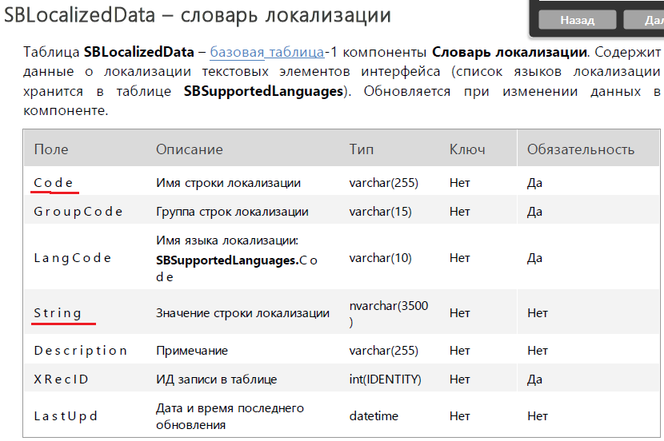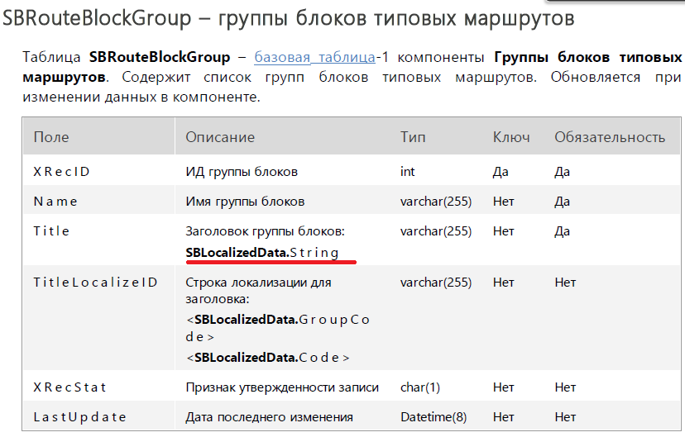

SBLocalizedData:



SBRouteBlockGroup:

